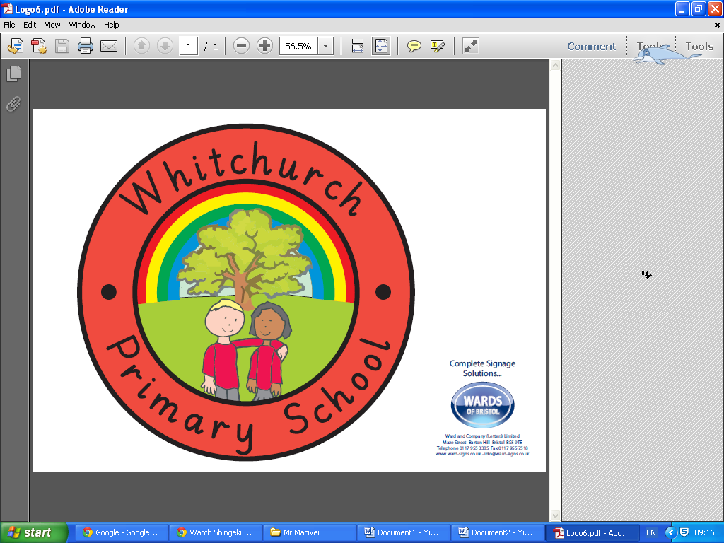

Newsletter 20

Www.whitchurchprimary.co.uk

Www.whitchurchpri.primaryblogger.co.uk

01275 833593

Www.whitchurchprimary.co.uk

Www.whitchurchpri.primaryblogger.co.uk

01275 833593

www.whitchurchprimary.co.uk

www.whitchurchpri.primaryblogger.co.uk

Tel: 01275 833593

2017/2018

08.02.18

Whitchurch Primary School

22 Bristol Road, BS14 0PT

**END OF TERM - This term will end tomorrow Friday 9th February, we return to school on Monday 19th February.**

**PARENT REPORTING –** Once again, children in Years 1 - 6 will bring home a slip showing their outcomes for this term tomorrow. The slip will show boxes for Reading, Writing, Maths, Attendance and Behaviour, Reading fluency, Handwriting, Spelling and Maths fluency, alongside a mark between 1 and 4, depending on how well they understood the learning. This slip will be used to keep you updated on your child’s progress.

**YEAR 3 AND 4 – CHURCH VISIT**

As part of their project on local history and geography this term, children in Year 3 and 4 visited St Nicholas Church this week and worked collaboratively on a cross-curricular project of the local area.



**YEARS 1 AND 2 –**

**INDIA DAY**

Children in Years 1 and 2 have been learning about India in their project this week. They have been tasting Indian food, colouring Mendi designs and trying out some Bollywood dancing!



**THIS WEEKS’ ATTENDANCE RESULTS!**

Reception: 84%

Year 1: 88.3%

Year 2: 93.9%

Year 3: 94.6%

THE WINNERS THIS WEEK ARE YEAR 3! Year 3 will receive 10 minutes extra play time!

THE HOUSE WITH THE HIGHEST ATTENDANCE THIS WEEK IS OAK WITH 92.9%

Year 4: 94.2%

Year 5: 92.3%

Year 6: 85.9%

**SCHOOL EXPANSION:** Thank you to all who attended the school expansion meeting on Tuesday in the school hall. Parents and members of the local community were able to give their thoughts, feelings and opinions to members of the council and myself. One question I was asked a number of times concerns how the children of our school will go through the school upon joining in the Reception year. Please note this is a scenario of what the plan could look like, which is dependant on a variety of factors

When the 45 intended children join our school for their Reception year, they will be in two separate classes:

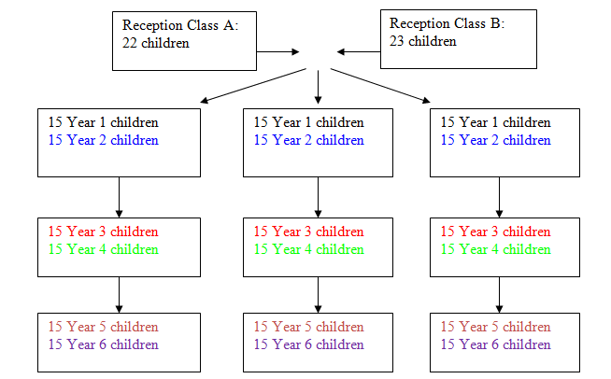

In time, this will be the model for class structure with mixed age classes. However, the September 2019 intake to Reception are likely to be in two smaller classes (23/22 children) for the duration of the Reception year and Year 1. After this, the 45 children in Year 1 and the 45 children in Year 2 (90 children) will be split into 3 classes of 30, with 15 Year 1 and 15 Year 2 in each class.

To be clear, if you are considering joining our school in September 2018, when your child joins Year 2, they are likely to be in mixed age classes.

This entry will also be placed on the school website to make all considering a place at our ‘rapidly improving’ school aware. Thank you.

**PRAISE AND SHOWCASE!**

Each week the school rewards children from each class with special certificates!

One will be awarded for excellent behaviour, the other for superb work, which will go into a ‘showcase’

book for visitors to view in the school office. Photos can be viewed on the website shortly!

This week’s children are:

YEAR 1: Jack has been praised – Sophia has received the showcase award

YEAR 2: Charlie has been praised – Sam has received the showcase award

YEAR 3: Evie has been praised – Dylan has received the showcase award

YEAR 4: Ben has been praised – Maja has received the showcase award

YEAR 5: Dylan has been praised – Ethan has received the showcase award

YEAR 6: Ella has been praised – Olivia has received the showcase award